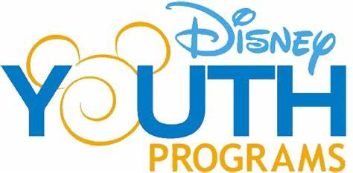

You're Instrumental | Disney Performing

Arts Workshops
Sight-read, prepare and record a polished performance of special Disney music selections in a studio environment like a professional musician. For middle/junior high and high school bands and orchestras.

Workshop Overview
Students learn how to get the most out of rehearsals and discover how to execute a pitch-perfect performance as they hone their sight-reading skills under the guidance of an experienced Disney teaching artist.
Your group will examine the skills, attitudes and priorities essential to musical excellence. This 2-1/2-hour workshop culminates in a very special finale—a recording of your ensemble performing Disney music, accompanied by footage from a classic Disney animated film.
Performers work toward musical and technical proficiency in a recording studio environment as they:
- Sight-read arrangements of Disney music ranging from Grade 1.5 to Grade 4
- Incorporate accuracy and expressiveness to maximize rehearsal productivity
- Emphasize intonation, balance and tone quality while following the conductor's interpretation
- Discuss the requirements of a studio recording environment and what is expected of performers
- Experience what life is like for a professional studio musician
Chairs, stands, a piano, amps and all large percussion instruments are provided. Music is scored for concert bands, string orchestras, full orchestras or combined concert band/string orchestras. Your Disney teaching artist will select music appropriate for your group's grade level in order to achieve musical success within a short rehearsal period.
Recommended for middle school, junior high and high school bands and orchestras.

National Core Arts Standards
Disney Performing Arts Workshops fulfill many of the National Core Arts Standards for creation, performing, responding and connecting. Review the standards explored through this experience.

